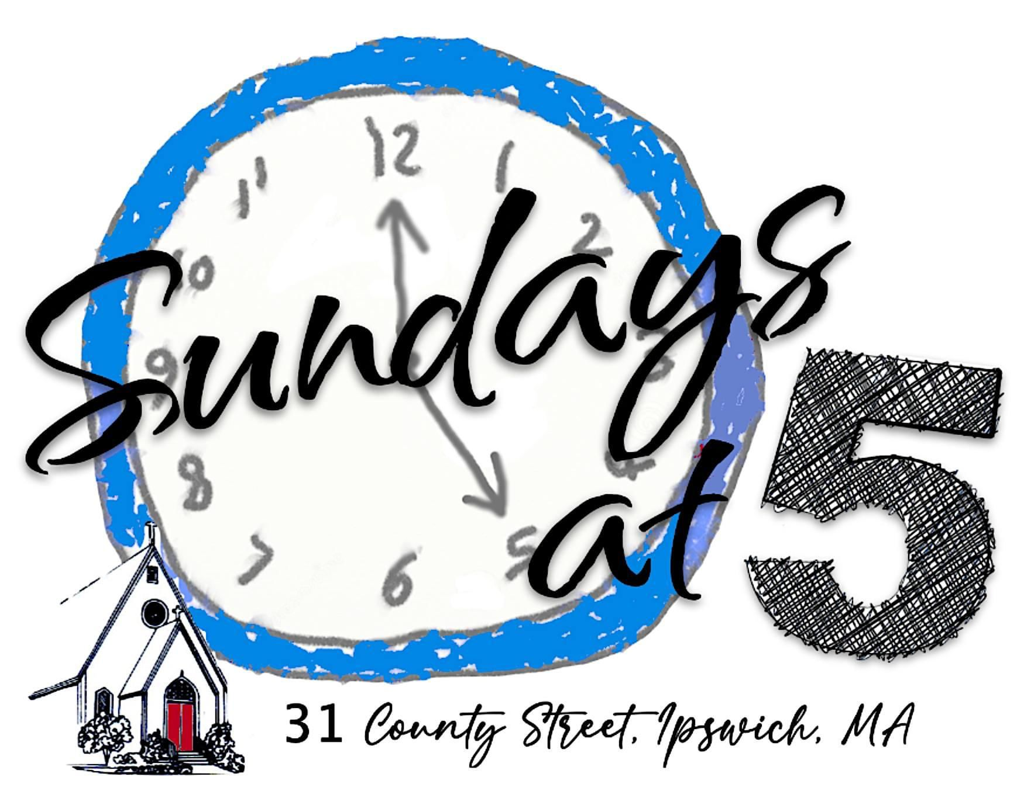
logo and artwork by Paula Jones

ASCENSION MEMORIAL CHURCH
A Parish of the
Episcopal Diocese of Massachusetts

Flourishing - Family - Community

To bear witness to the Spirit of God
we see in Jesus as an Episcopal community open to all,
centered in worship, Christian education, table fellowship,
care for the environment,
and compassion for neighbors local and global

May 7, 2023

P.O. 547, 31 County Street
Ipswich, MA 01938
e-mail: amcipswich@verizon.net
978-356-2560
www.amcipswich.org
The Candles

The Singing Bowl
Take a moment to listen to the sound of the bowl
as it echoes and reverberates through the church and slowly fades away.

Opening Invocation

As we gather here in this harbor of safety, we give thanks for fellowship and family.
We ask for strength in all adversity and the inspiration to love and care for one another.
Let our hearts be filled with peace and understanding
so that as we journey onwards, we pour out love and grace to others.
We ask that our souls catch the wind of the Spirit
so that we may carry the promise of peace and joy to all the earth.

Welcome

Prayer Cards

Help me to be a trustworthy person by…..
You can indicate on the card if you wish your prayers to remain private.

Music Meditation

Reading - Amos and Boris - William Steig

The most important decisions we make often begin with a willingness to trust in taking the first step. TRUST serves as the central theme of our time together tonight and TRUST brings together Amos and Boris, a mouse and a whale who save each other from harm by learning to trust one another.

Reflection Rev’d Brad Clark

Song. Getting To Know You - Rogers and Hammerstein Vicki Hughes & Lucas Callahan

Getting to know you,
Getting to know all about you.
Getting to like you,
Getting to hope you like me.
Getting to know you,
Putting it my way,
But nicely,
You are precisely,
My cup of tea.

Getting to know you,
Getting to know all about you.
Getting to like you,
Getting to hope you like me.
Getting to know you,
Putting it my way,
But nicely,
You are precisely,
My cup of tea.

Getting to know you,
Getting to feel free and easy
When I am with you,
Getting to know what to say
Haven't you noticed
Suddenly I'm bright and breezy?
Because of all the beautiful and new
Things I'm learning about you
Day by day.

The Prayers

The Blessing Over the Bread

Just as rain and snow fall from the heavens and return not again, but water the earth,
bringing forth life and giving growth, seed for sowing and bread for eating;

So is the love that flows through us, bringing us life and giving us growth;

It will not return empty, but will break open our life as a gift for feeding others,
just as we now break open this loaf of bread as a gift for feeding one another.

During the breaking of bread, please feel warmly invited to come forward to receive a
piece of bread as a sign of your place in the family of things

Blessing & Dismissal

Life is short, and we do not have too much time
to gladden the hearts of those who walk the way with us;
so be swift to love, make haste to be kind,
and may the Blessing of the One who created us,
redeemed us, and who walks always with us,
be with us and all those we love, this day and always. Amen.

The Candles

